DEV BLOG
C++ PROJECT 1
Name of project: Timberland
Project Inspiration.
h
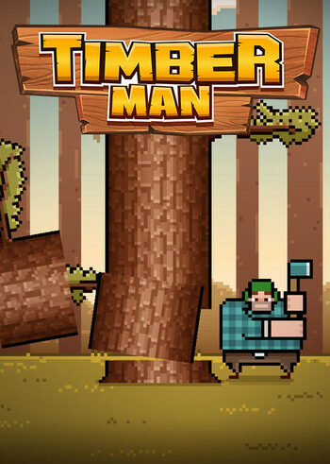
This game takes heavy inspiration from the game Timberman available on PC and other gaming consoles, the main purpose of this game is to break an infinite tree to collect points, whilst avoiding the branches, however, to add another layer of difficulty the player must hit the tree under a certain amount of time to avoid the timer running out, the two ways to end the game is to either be hit by a branch or let the timer run out, sending you into the end game credits where it will show you your high score and the score from that game you just played, at this stage you may repeat the game to get a better high score.
The game also includes a nice colour palette which appeals to the gamer, with good features like the menu and help screen to guide the player through the game and stop them from just quitting on opening the game.
Figure 1: Timberman
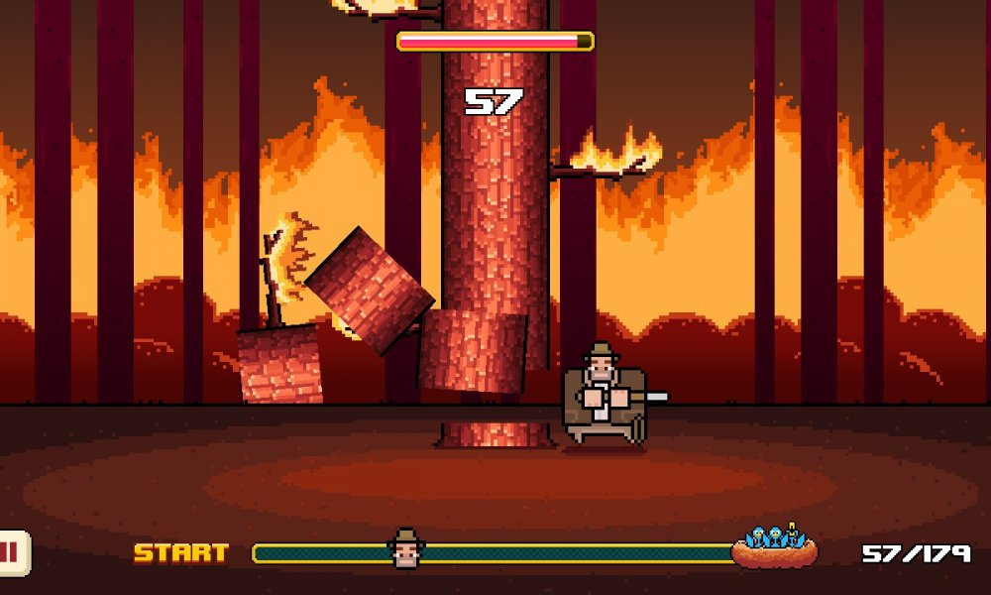
- Time is always decreasing.
- You can increase time by chopping the tree.
- Chopping causes the branches to fall.
- The player move around the tree.
- The player must avoid the branches.
- Player animations as well as tree animations.
- Score goes up as player hits the tree.
Figure 2: Timberman in game screenshot

Super Mario World.
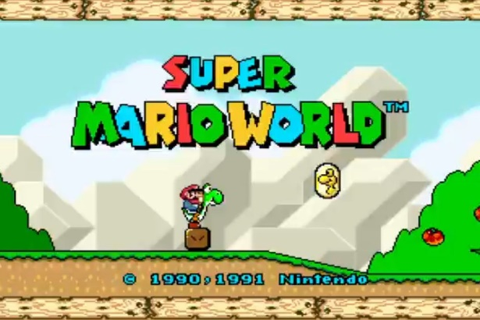
Super Mario World is available on PC and other game consoles, it makes exceptional use of progression by adding a map to allow the player to realise how far they are in the game, and although it is simple, it makes the game feel achieving and gives the player a boost to spend more time to finish the game.
Another feature is the power ups, it gives each playthrough something unique to give the player a surprise when playing, therefore worlds do not get boring to repeat.
Figure 3: Super Mario World
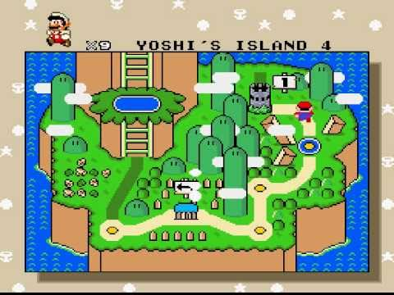
- Interactive world UI.
Figure 4: Super Mario World level selection screenshot.
- Player unique abilities.
- Unique abilities are selected randomly.
- Player progression is based on skill to complete previous level.
- Can repeat previously completed levels for a better score.
- Hidden bonus levels.
- Character animation to show progression in the world.
- End level to show how far from game completion
Game 3.
Something put here.

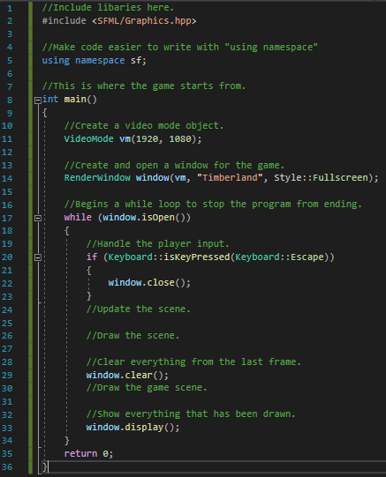
30/09/21
Today I made my first attempt to write code in C++, following a tutorial from a book I was reading, I was able to configure Visual Studio 2019 with SFML, and therefore able to use their libraries, in this I made a 1920 by 1080-pixel screen application called Timberland pop up. This then puts the program in a while loop whilst the application is running, and then once the user inputs escape, the program closes as expected.

05/10/21
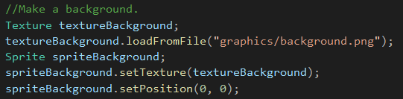
So having some more time I’ve now added some graphics to the screen, on the image it is shown how I set the sprite, I make a texture, find the image in my files to apply to the texture, and then set a sprite to that texture and apply the original position of this sprite.
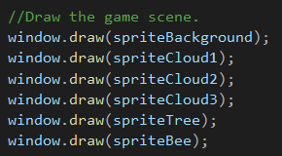
In the next image you can see how I’ve used the SFML libraries to use their window method and draw the sprites to my screen, I just call the sprite we set earlier and pass it through to the function.

